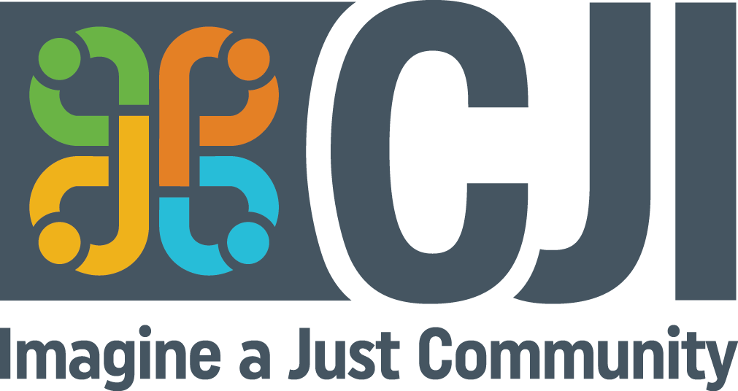
CJI Participant Complaints Process
Community Justice Initiatives (CJI) is committed to providing respectful, accessible, and responsive services. Program participants may occasionally disagree with or feel dissatisfied with the services they receive. CJI welcomes feedback and concerns as an opportunity to improve our programs and services.
This complaints process is intended to ensure that concerns are addressed promptly, fairly, and respectfully.
Accessibility
CJI is committed to providing accessible services in accordance with the Accessibility for Ontarians with Disabilities Act (AODA). Accessible formats and communication supports are available upon request by calling 519-744-6549 or by emailing info@cjiwr.com and asking for the Health and Safety Representative. Individuals requiring accommodation to participate in the complaints process are encouraged to contact us so that appropriate arrangements can be made.
Complaints may be submitted in person, by telephone, by email, in writing, or through another communication method that meets the participant's accessibility needs. Complaints will be handled confidentially to the extent possible, and information will be shared only as necessary to address the concern.
Complaint Resolution Process for Program Participants
- Contact the Service Coordinator
Each program area has a designated Service Coordinator. Contact information is available on the CJI website (www.cjiwr.com) or by calling 519-744-6549.
Participants are encouraged to first discuss their concerns with the Service Coordinator. The Service Coordinator will make every effort to listen to the concerns, understand the issues, and work collaboratively with the participant to resolve them. The Service Coordinator will acknowledge the complaint within five (5) working days and make every effort to work collaboratively toward resolution.
If a participant does not wish to discuss the concern with the Service Coordinator, or feels the concern has not been adequately addressed, they may contact the Director of Programs.
- Contact the Director of Programs
Contact information for the Director of Programs is available on the CJI website (www.cjiwr.com) or by calling 519-744-6549.
Within five (5) working days of receiving the complaint, the Director of Programs will contact the participant. The Director of Programs will make every effort to understand the concerns and work collaboratively with the participant toward a resolution.
Where appropriate, the Director of Programs may arrange a meeting involving the participant and the Service Coordinator to support communication and mutual understanding.
If the participant is not satisfied with the process or outcome, they may request a review by the Executive Director.
- Contact the Executive Director
Contact information for the Executive Director is available on the CJI website (www.cjiwr.com) or by calling 519-744-6549.
Participants may submit their concerns to the Executive Director in writing, by email, by telephone, or through another accessible communication method. Assistance with documenting concerns will be provided upon request.
Within five (5) working days of receiving the complaint, the Executive Director will contact the participant. The Executive Director will make every effort to understand the concerns and work collaboratively with the participant to seek resolution.
If the participant remains dissatisfied with the process and/or outcome, they may request further review through the appropriate funding ministry, organization, or oversight body. The Executive Director will provide information regarding the appropriate contact person or organization.
Response to Complaints
CJI will make every effort to respond to complaints in a manner that respects the participant's accessibility needs. Upon request, responses and related information will be provided in accessible formats and with appropriate communication supports.

